Which state of matter has the highest kinetic energy?

Solid, Liquid or Gas

Which state of matter has the lowest kinetic energy?

Solid, Liquid or Gas

Give a simple definition of

Sublimation

Give a simple definition of

Diffusion

What is this simple machine?

Name the 6 simple machines

What is this simple machine?

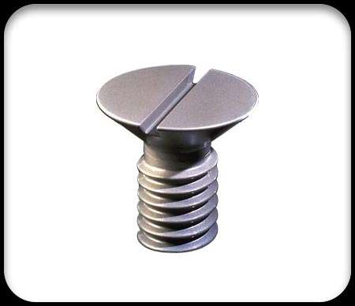
What is this simple machine?
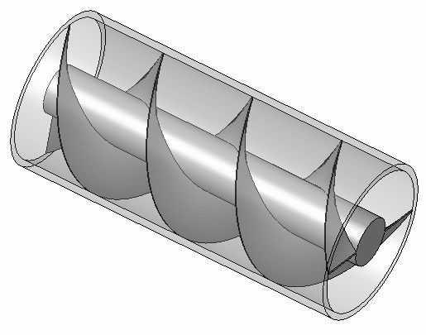

In physics, a wedge is defined as?

In physics, a screw is defined as?

Solid

Gas

The movement of particles from high concentration to low concentration.

Changing directly from solid to gas.

Inclined plane
Screw
Pulley
Lever
Wedge
Wheel and Axle

Inclined plane

Screw

Screw

An inclined plane wrapped around a center pole.

A pair of inclined planes set back-to-back.

